CS-102 Recitation 3 Homework

Arseniy Dolgin ([aad548@nyu.edu](mailto:aad548@nyu.edu)).

Q1 Answer:

The following method does not have a base case, therefore it will keep calling itself until computer runs out of memory (similar to an infinite loop).

Q2, Q3 Answers:

See programs attached as Ex2.java and Ex3.java.

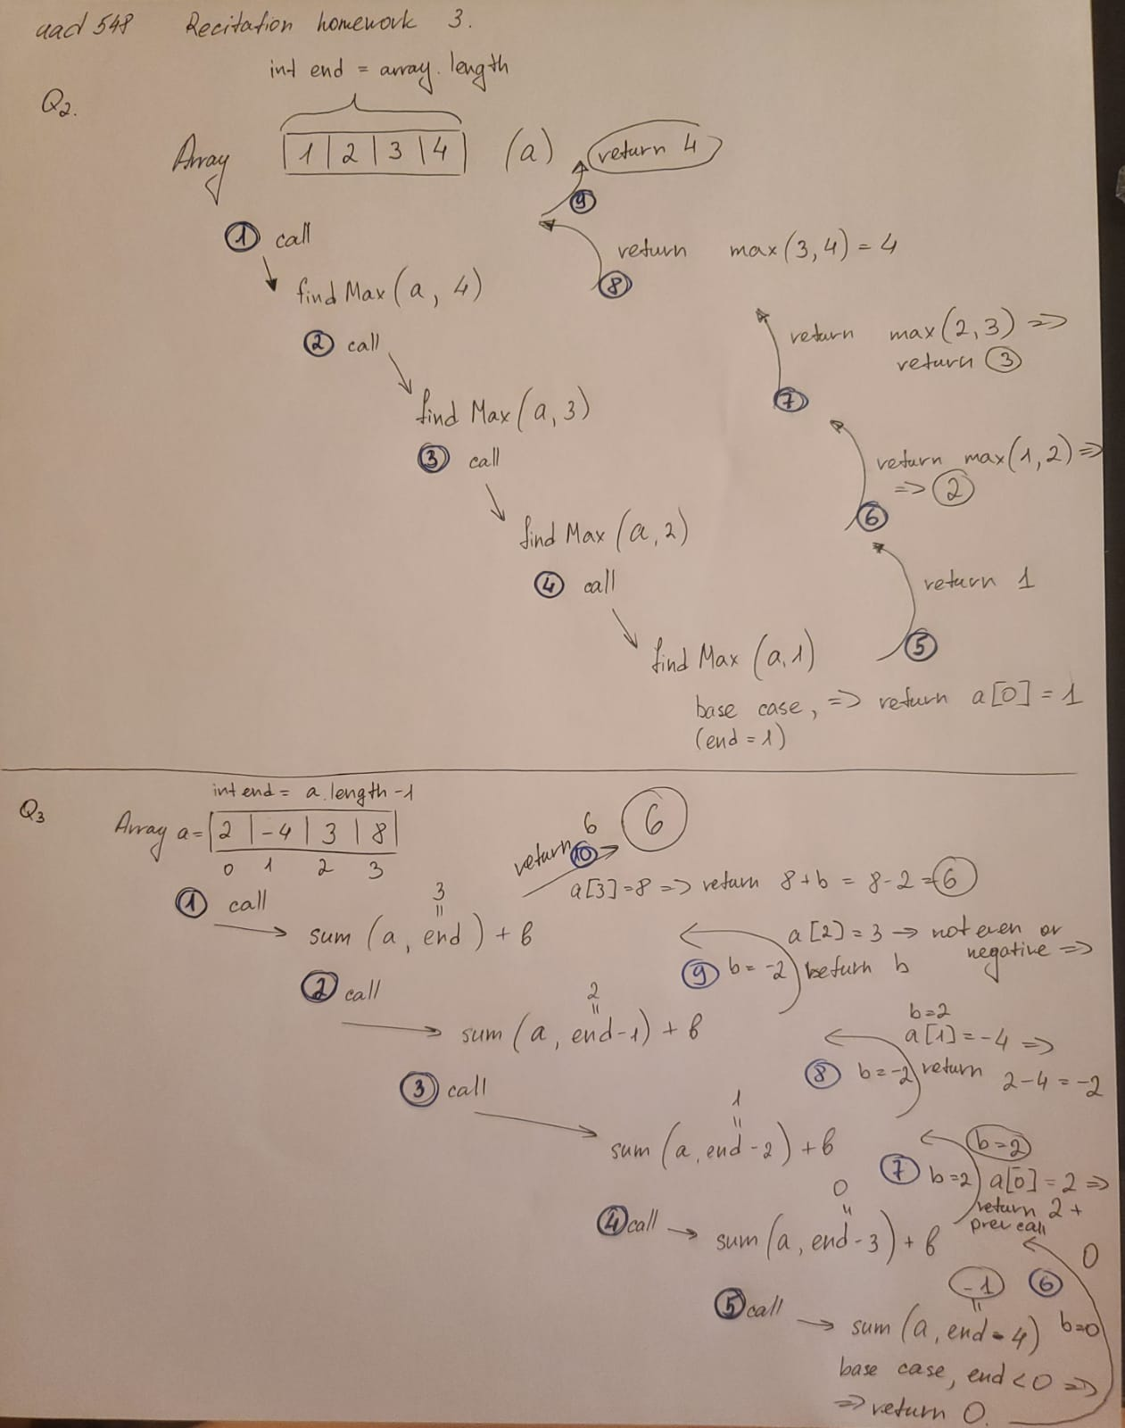Below is the stack trace diagrams for the questions: